Customers in a Queue
Service area 1 | Service area 2 | Service area 3

Enter here
Customers at airlines and banks typically join a single queue. They move through the queue and eventually take their place at one of the open counters or "service areas." Each customer then conducts his/her business and leaves. The situation is diagrammed here:

Suppose an airline or a bank wants to measure the wait-times to serve each customer, from the minute they enter to the minute they leave. The airline hires you to program a simulation of the situation.

- You need one queue.
- You need an array of the correct size to represent the service areas.
- You need to know how often, the frequency per minute, that customers join the queue.
- You need to know how long it takes (a random number) to conduct the customer's business after they arrive at the service area. We will count each minute down to 0, after which the customer leaves.
- You need to store the time at which the customer entered the queue.
- 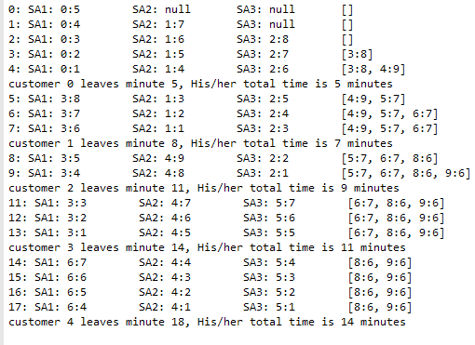You need to calculate how long the customer spent getting served (the total wait time), from the minute they entered to the minute they left.
- You need to know how long to run the simulation.

For each minute write to a file:
- Each minute, starting from 0.
- The service areas serving their customers.
Each customer shows arrival time and the time
remaining until they complete their business
and leave.
- The queue with its customers,
showing the arrival time and the time they need
to complete their business.

outfile.print(min + ": ");
for(int i=0; i< atServiceWindow.length; i++)
{
outfile.printf("SA%s: %-11s", i+1,atServiceWindow[i]);
}
outfile.println("" + queue);

- Write in the file when a customer leaves, Ex:
customer 0 leaves minute 5, His/her total time is 5 minutes

Display these calculations to the screen (and at the end of your simulation in the file):
- How many service areas are there?
- Probability of arrival.
- Number of minutes.
- The total customers served.
- The average wait time per customer.
- The longest wait time of any customer.
- The length of the longest queue of customers.

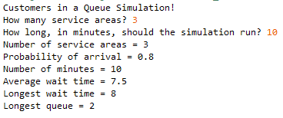

You need to generate two random numbers in this lab:
- whether a customer joins the queue during that minute. Let's set the frequency at an 80% chance per minute.
- how long it takes to conduct the customer's business after they get to the service area. Let's generate a random integer between 3 and 9 minutes, inclusive.
The Customer class
It seems like a Customer class would be a good way to model the situation.

What private data should the Customer store?

What methods do you need?

Algorithm in the serveTheCustomers method
What happens in each minute? What might happen in each minute?

What happens to customers in the queue and service areas at the end of the day? Do we empty the queue or just not serve them?

Hints for passing the autograder’s tests:
Your outfile must be in the right format! The autograder will process your outfile to count your number of customers, longest wait time, longest queue, and total wait time.
- Use the given variables and methods, not your own.
- Start the outfile from minute 0.
- Outfile every minute, even if there are empty queues, []
- First do the processing on the queue, then outfile the queue.
- Debugging strategy: change the CHANCE_OF_CUSTOMER to 0.01 and run it. Now the activity recorded in your outfile is so small that you can look and count for yourself. Also, you may enter 5-10 minutes, now the activity recorded in your outfile is so small that you can look and count for yourself.

Please look at the sample results provided to understand better the algorithm.

Extension: implement the behavior to continue serving until all the services are empty and the queue is empty. Then at the end display the overtime in minutes like:
